**Networking**

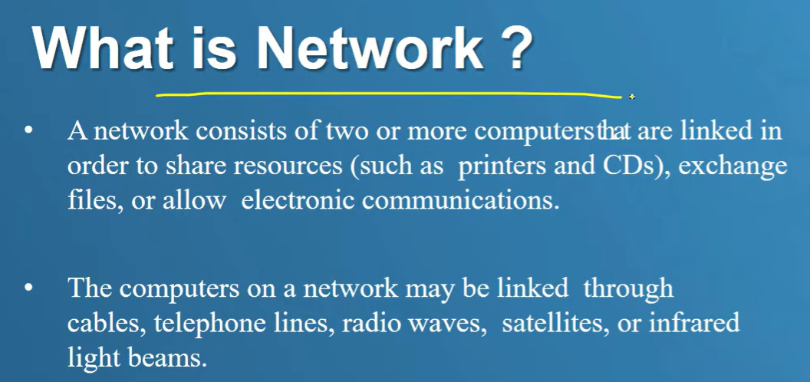

**INTERNET SERVICE PROVIDER**

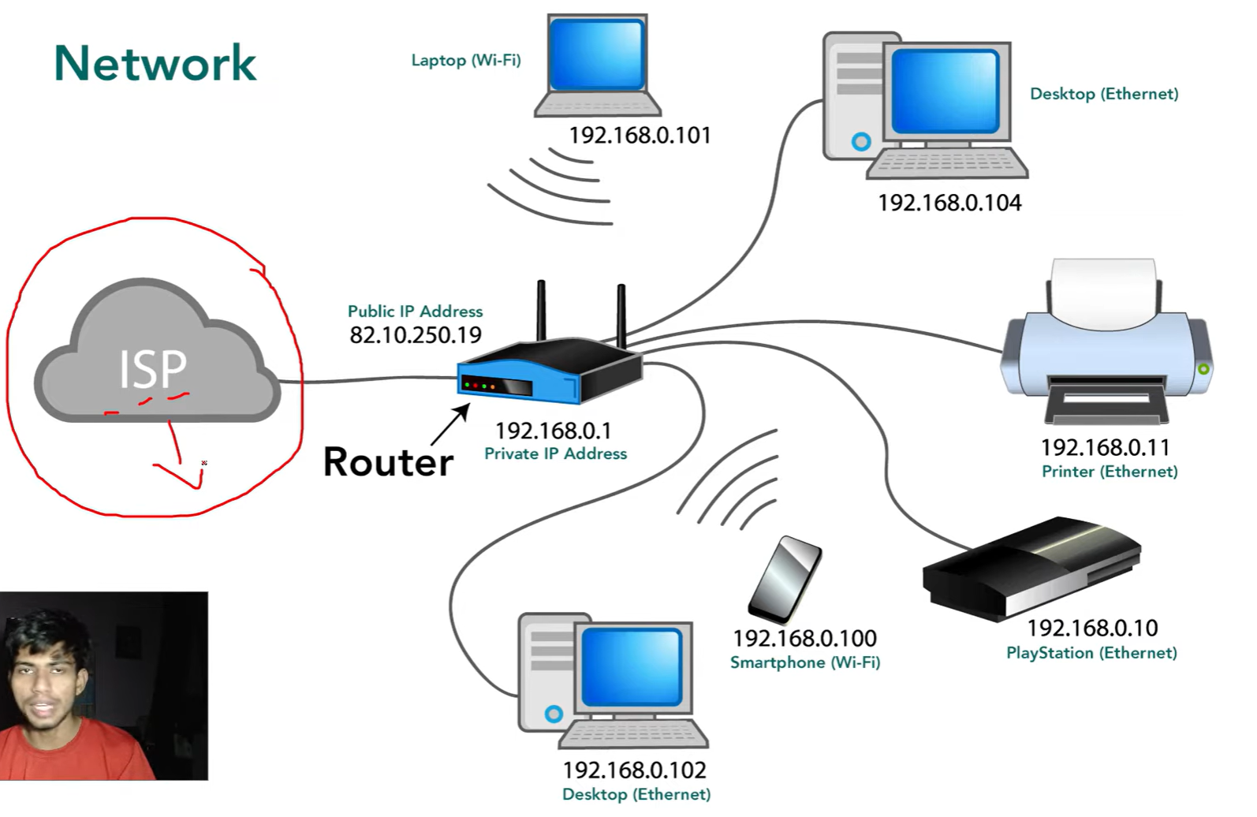 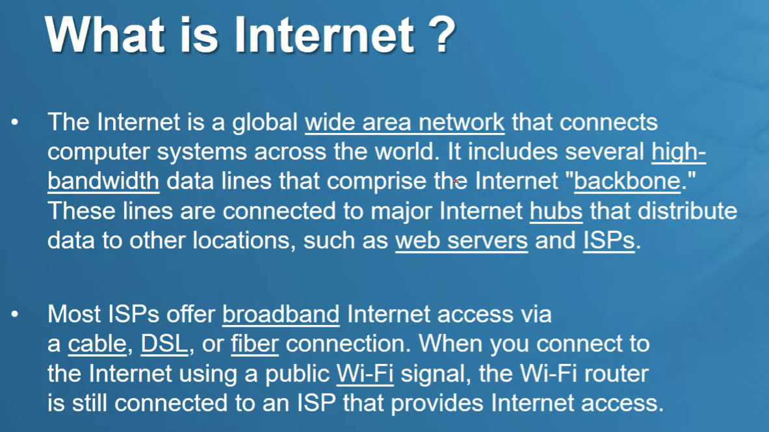

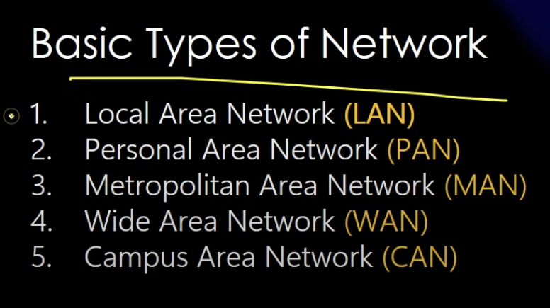

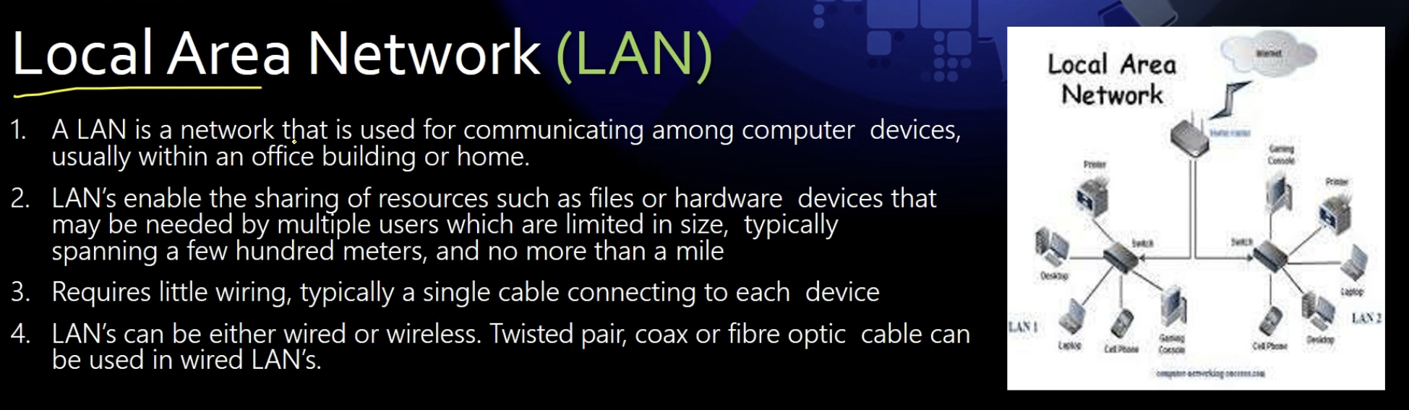

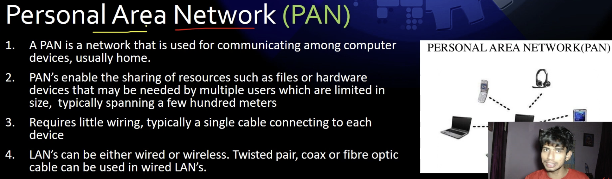

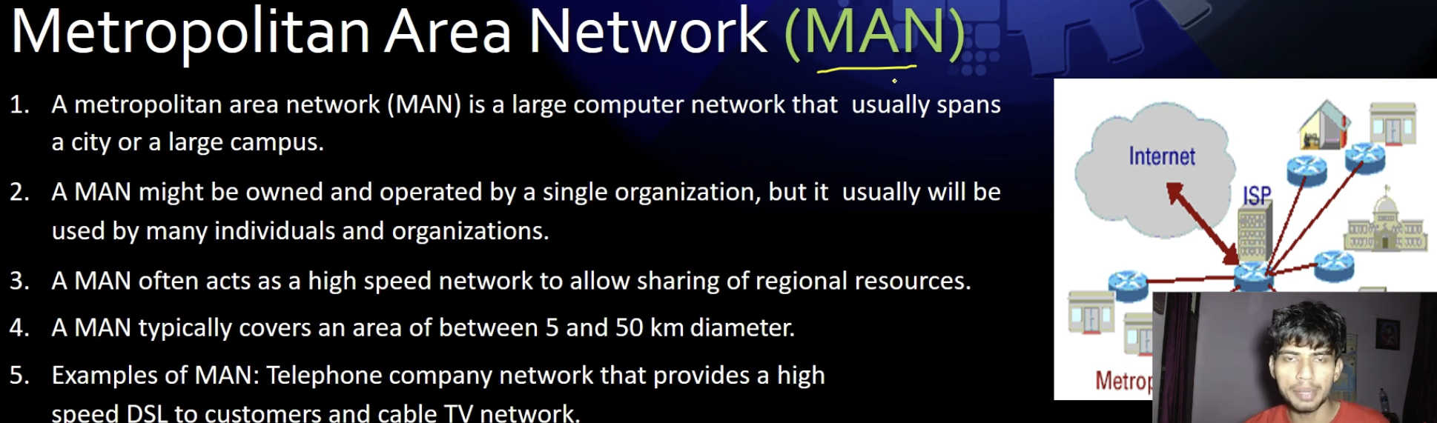

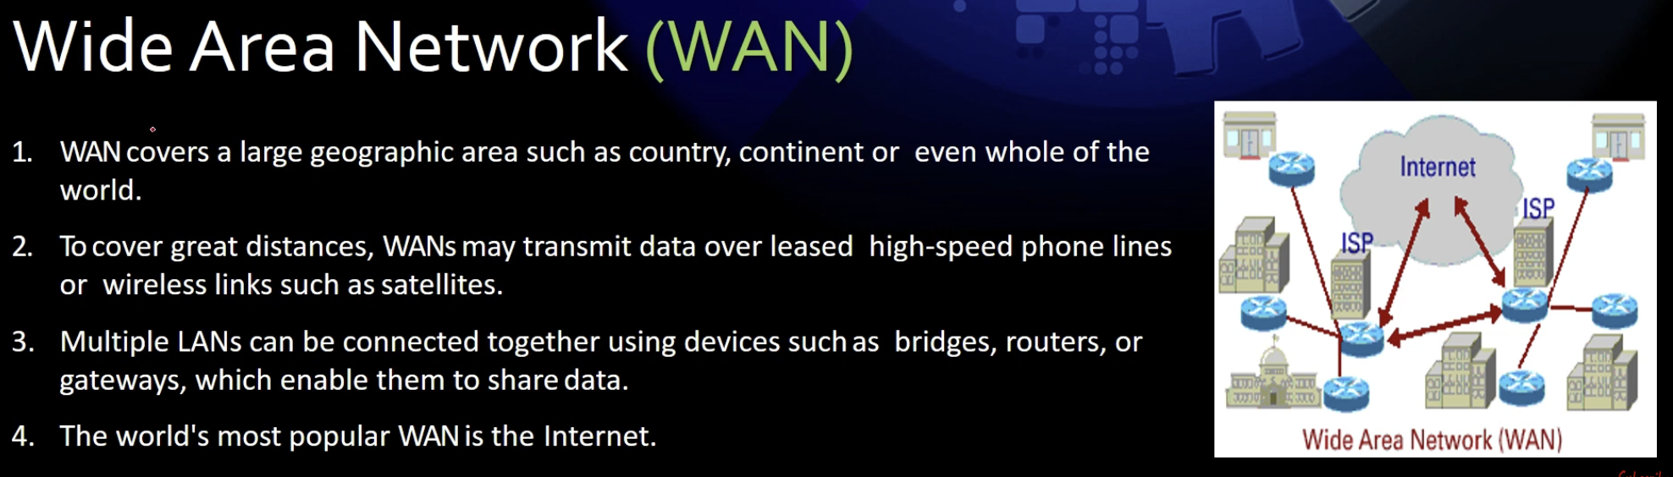

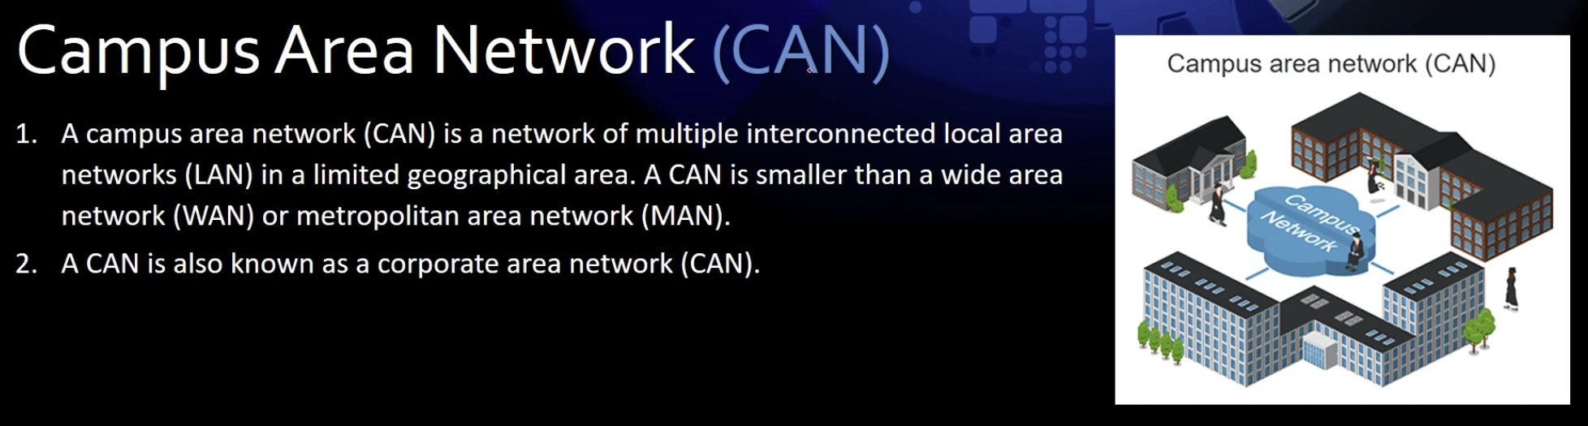

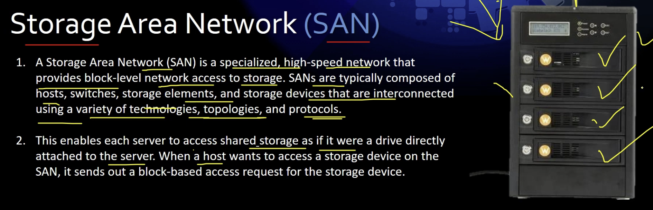

**When you type something in Google and hit search, the following steps occur:**

1. **DNS Resolution: Your browser first checks if it already knows the IP address of Google's servers. If not, it queries a DNS (Domain Name System) server to convert www.google.com into an IP address.**
2. **Network Routing:**
   * **Your request travels from your device (which has a private IP) to your router (which also has a private IP).**
   * **The router forwards the request to your ISP (Internet Service Provider), which assigns you a public IP.**
   * **The request then travels through multiple network hops, including ISPs, data centers, and undersea cables, until it reaches Google’s servers (often in the nearest data center, not necessarily the USA).**
3. **Processing at Google's Server:**
   * **Google's servers process your query using their search algorithms.**
   * **The results are retrieved from their massive database.**
4. **Response Transmission:**
   * **The response data follows the reverse path, traveling back through ISPs, routers, and finally reaching your device.**
5. **Rendering the Results:**
   * **Your browser receives the response and displays the search results.**

**Check the Network Path**

**To see how your request travels, you can open CMD (Command Prompt) and use:**

* **tracert google.com → Shows the path your request takes to reach Google’s servers.**
* **nslookup google.com → Resolves Google's domain to an IP address.**

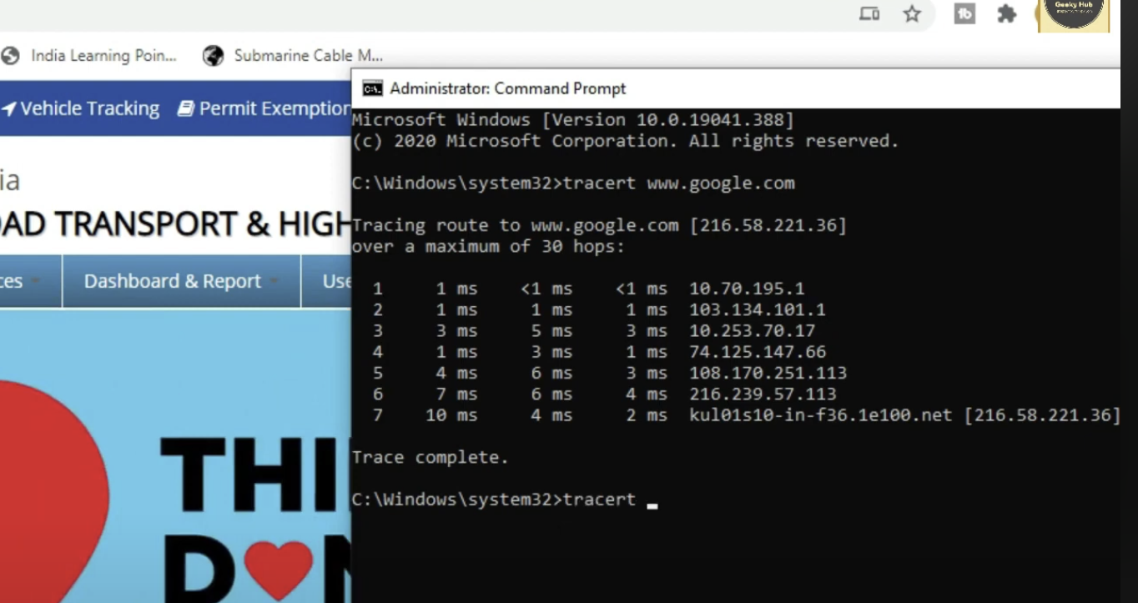

**Government officially will keep their server in india because of security.**

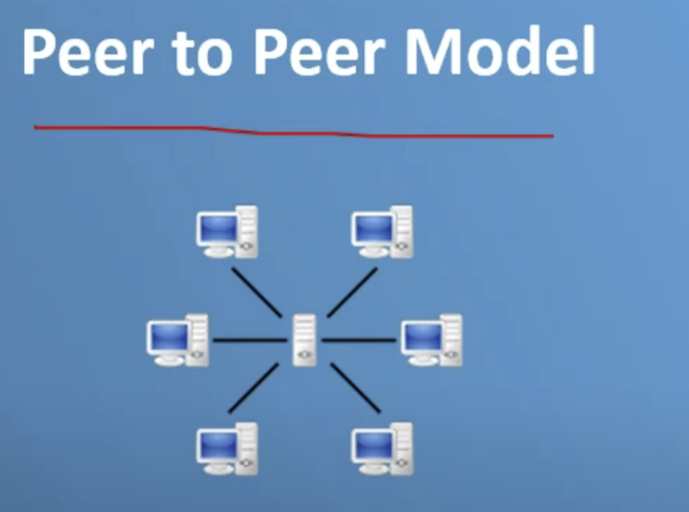

**It is independent model and there is no restrictions.**

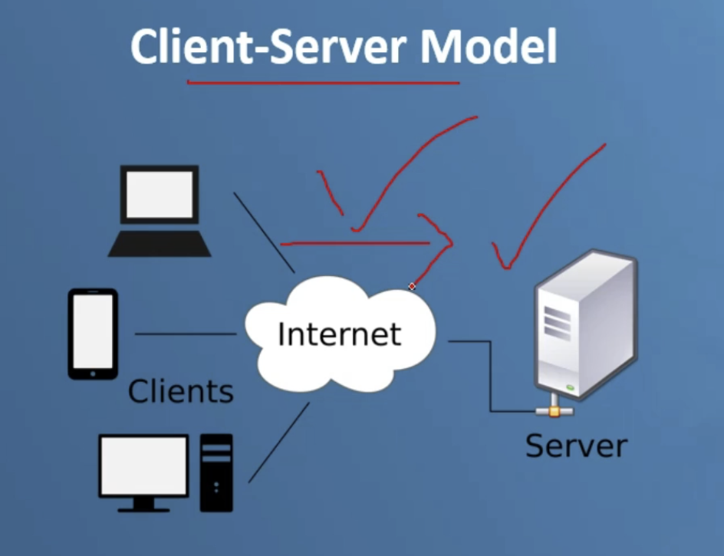

**This is dependent model where administrator has control.**

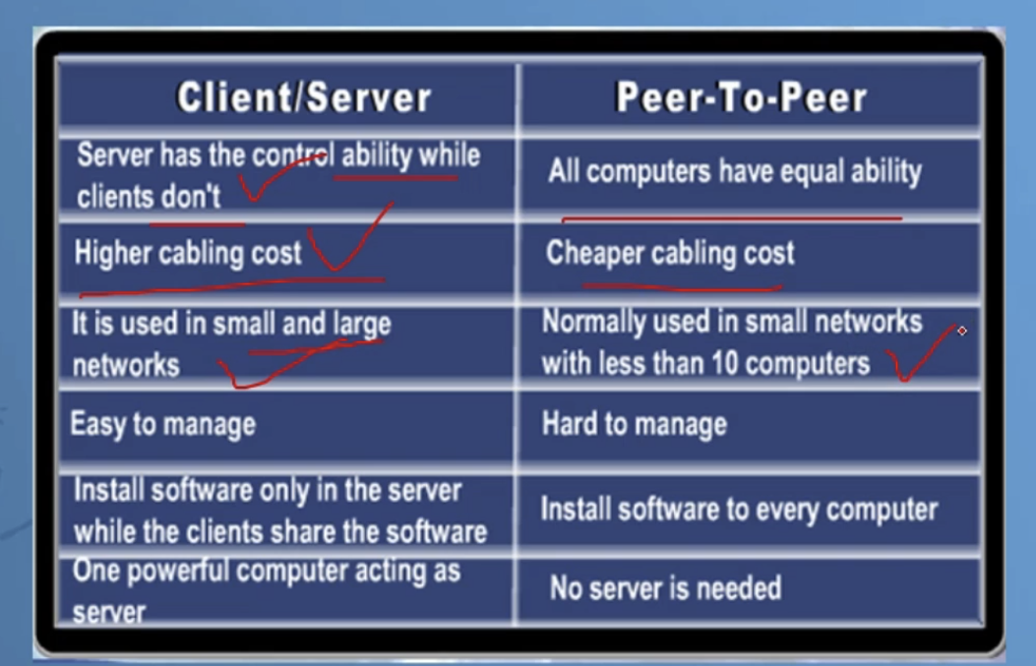

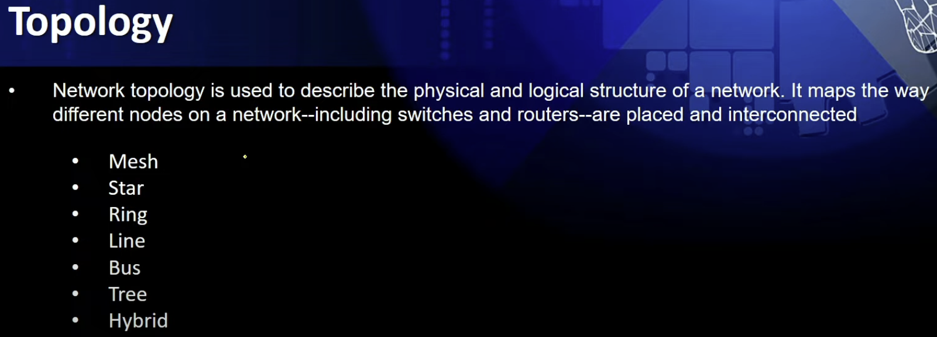

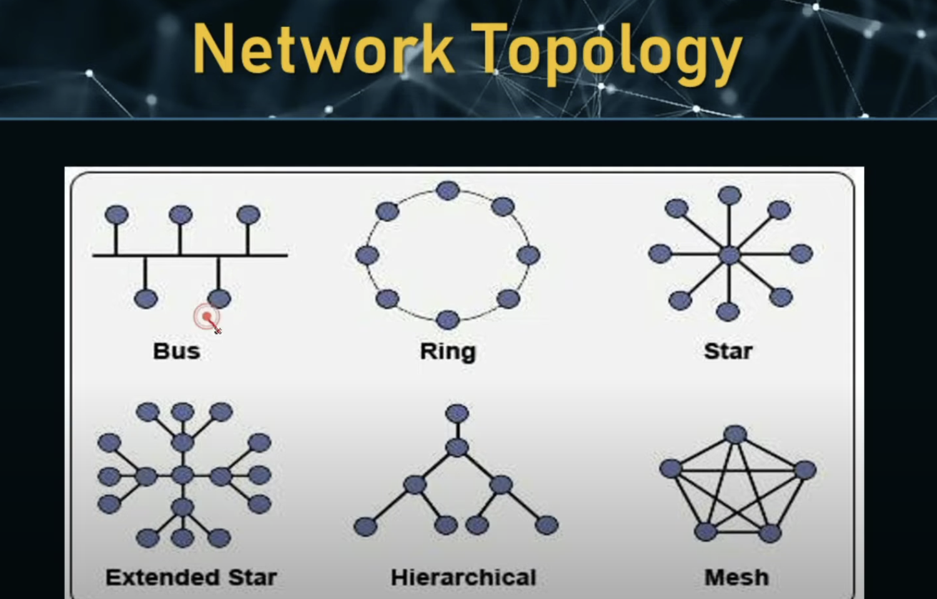

**Previously there was ip address but know iCANN how does this redirect to some domain**

